Classical conditioning (also known as Pavlovian or respondent conditioning) is a learning process in which an innate response to a potent stimulus comes to be elicited in response to a previously neutral stimulus; this is achieved by repeated pairings of the neutral stimulus with the potent stimulus. The basic facts about classical conditioning were discovered by Ivan Pavlov through his famous experiments with dogs. Together with operant conditioning, classical conditioning became the foundation of Behaviorism, a school of psychology which was dominant in the mid-20th century and is still an important influence on the practice of psychological therapy and the study of animal behaviour (ethology). Classical conditioning is now the best understood of the basic learning processes, and its neural substrates are beginning to be understood.

Definition
Classical conditioning occurs when a conditioned stimulus is paired with an unconditioned stimulus. Usually, the conditioned stimulus (CS) is a neutral stimulus (e.g., the sound of a tuning fork), the unconditioned stimulus (US) is biologically potent (e.g., the taste of food) and the unconditioned response (UR) to the unconditioned stimulus is an unlearned reflex response (e.g., salivation). After pairing is repeated (some learning may occur already after only one pairing), the organism exhibits a conditioned response (CR) to the conditioned stimulus when the conditioned stimulus is presented alone. The conditioned response is usually similar to the unconditioned response (see below), but unlike the unconditioned response, it must be acquired through experience and is relatively impermanent.^{[1]}
In classical conditioning, the conditioned stimulus is not simply connected to the unconditioned response; the conditioned response usually differs in some way from the unconditioned response, sometimes significantly. For this and other reasons, learning theorists commonly suggest that the conditioned stimulus comes to signal or predict the unconditioned stimulus, and go on to analyze the consequences of this signal.^{[2]} Robert A. Rescorla provided a clear summary of this change in thinking, and its implications, in his 1988 article "Pavlovian conditioning: It's not what you think it is."^{[3]} Despite its widespread acceptance, Rescorla's thesis may not be defensible.^{[4]}
Classical conditioning differs from operant or instrumental conditioning: in classical conditioning, behavioral responses are elicited by antecedent stimuli, whereas in operant conditioning behaviors are strengthened or weakened by their consequences (i.e., reward or punishment).^{[5]}

Procedures
Ivan Pavlov provided the most famous example of classical conditioning, although Edwin Twitmyer published his findings a year earlier (a case of simultaneous discovery).^{[6]} During his research on the physiology of digestion in dogs, Pavlov developed a procedure that enabled him to study the digestive processes of animals over long periods of time. He redirected the animal’s digestive fluids outside the body, where they could be measured. Pavlov noticed that the dogs in the experiment began to salivate in the presence of the technician who normally fed them, rather than simply salivating in the presence of food. Pavlov called the dogs' anticipatory salivation "psychic secretion." From his observations he predicted that a stimulus could become associated with food and cause salivation on its own, if a particular stimulus in the dog's surroundings was present when the dog was given food. In his initial experiments, Pavlov presented a stimulus and then gave the dog food; after a few repetitions, the dogs started to salivate in response to the stimulus. Pavlov called the stimulus the conditioned (or conditional) stimulus (CS) because its effects depend on its association with food.^{[7]} He called the food the unconditioned stimulus (US) because its effects did not depend on previous experience. Likewise, the response to the CS was the conditioned response (CR) and that to the US was the unconditioned response (UR). The timing between the presentation of the CS and US affects both the learning and the performance of the conditioned response. Pavlov found that the shorter the interval between the CS (e.g. metronome) and the appearance of the US (e.g.food), the stronger and quicker the dog learned the conditioned response.^{[8]}
As noted earlier, it is often thought that the conditioned response is a replica of the unconditioned response, but Pavlov noted that saliva produced by the CS differs in composition from what is produced by the US. In fact, the CR may be any new response to the previously neutral CS that can be clearly linked to experience with the conditional relationship of CS and US.^{[3][5]} It was also thought that repeated pairings are necessary for conditioning to emerge, however many CRs can be learned with a single trial as in fear conditioning andtaste aversion learning.
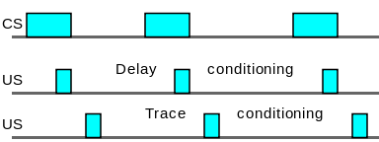
Diagram representing forward conditioning. The time interval increases from left to right.

Forward conditioning
Learning is fastest in forward conditioning. During forward conditioning, the onset of the CS precedes the onset of the US in order to signal that the US will follow,Two common forms of forward conditioning are delay and trace conditioning.
- Delay conditioning: In delay conditioning the CS is presented and is overlapped by the presentation of the US.
- Trace conditioning: During trace conditioning the CS and US do not overlap. Instead, the CS begins and ends before the US is presented. The stimulus-free period is called the trace interval. It may also be called theconditioning interval. For example: If you sound a buzzer for 5 seconds and then, a second later, puff air into a person's eye, the person will blink. After several pairings of the buzzer and puff the person will blink at the sound of the buzzer alone.
The difference between trace conditioning and delay conditioning is that in the delayed procedure the CS and US overlap.
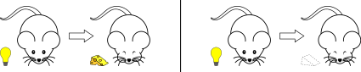

Simultaneous conditioning[edit]
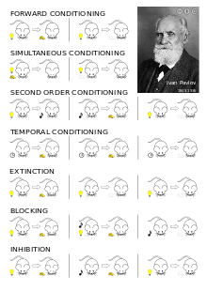
Classical conditioning procedures and effects
During simultaneous conditioning, the CS and US are presented and terminated at the same time.
For example: If you ring a bell and blow a puff of air into a person’s eye at the same moment, you have accomplished to coincide the CS and US.
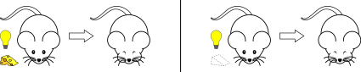

Second-order and higher-order conditioning
This form of conditioning follows a two-step procedure. First a neutral stimulus ("CS1") comes to signal a US through forward conditioning. Then a second neutral stimulus ("CS2") is paired with the first (CS1) and comes to yield its own conditioned response.^{[11]} For example: a bell might be paired with food until the bell elicits salivation. If a light is then paired with the bell, then the light may come to elicit salivation as well. The bell is the CS1 and the food is the US. The light becomes the CS2 once it is paired with the CS1
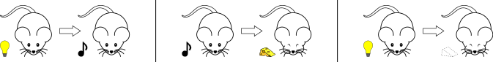

Backward conditioning
Backward conditioning occurs when a CS immediately follows a US.^{[9]} Unlike the usual conditioning procedure, in which the CS precedes the US, the conditioned response given to the CS tends to be inhibitory. This presumably happens because the CS serves as a signal that the US has ended, rather than as a signal that the US is about to appear.^{[12]} For example, a puff of air directed at a person's eye could be followed by the sound of a buzzer.

Temporal conditioning
In temporal conditioning a US is presented at regular intervals, for instance every 10 minutes. Conditioning is said to have occurred when the CR tends to occur shortly before each US. This suggests that animals have a biological clock that can serve as a CS. This method has also been used to study timing ability in animals. (see Animal cognition).
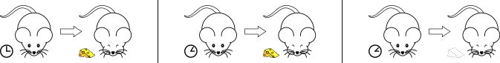

Zero contingency procedure
In this procedure, the CS is paired with the US, but the US also occurs at other times. If this occurs, it is predicted that the US is likely to happen in the absence of the CS. In other words, the CS does not "predict" the US. In this case, conditioning fails and the CS does not come to elicit a CR.^{[13]} This finding – that prediction rather than CS-US pairing is the key to conditioning – greatly influenced subsequent conditioning research and theory.

Extinction
In the extinction procedure, the CS is presented repeatedly in the absence of a US. This is done after a CS has been conditioned by one of the methods above. When this is done the CR frequency eventually returns to pre-training levels. However, spontaneous recovery (and other related phenomena, see "Recovery from extinction" below) show that extinction does not completely eliminate the effects of the prior conditioning. Spontaneous recovery is when there is a sudden appearance of the (CR) after extinction occurs. These phenomena can be explained by postulating accumulation of inhibition when a weak stimulus is presented.

Phenomena observed

Acquisition
During acquisition the CS and US are paired as described above. The extent of conditioning may be tracked by test trials. In these test trials, the CS is presented alone and the CR is measured. A single CS-US pairing may suffice to yield a CR on a test, but usually a number of pairings are necessary. This repeated number of trials increase the strength and/or frequency of the CR gradually. The speed of conditioning depends on a number of factors, such as the nature and strength of both the CS and the US, previous experience and the animal's motivational state^{[2][5]} Acquisition may occur with a single pairing of the CS and US, but usually, there is a gradual increase in the conditioned response to the CS. This slows down the process as it nears completion.^{[14]}

Extinction
In order to make a learned behavior disappear, the experimenter must present a CS alone, without the presence of the US. Once this process is repeated continuously, eventually, the CS will stop eliciting a CR. This means that the CR has been "extinguished".^{[2]}
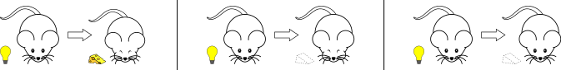

External inhibition
External inhibition may be observed if a strong or unfamiliar stimulus is presented just before, or at the same time as, the CS. This causes a reduction in the conditioned response to the CS.

Recovery from extinction
Several procedures lead to the recovery of an extinguished CR. The following examples assume that the CS has first been conditioned and that this has been followed by extinction of the CR as described above. These procedures illustrate that the extinction procedure does not completely eliminate the effect of conditioning^{[5]}
- Reacquisition:
If the CS is again paired with the US, a CR is again acquired, but this second acquisition usually happens much faster than the first one.
- Spontaneous recovery:
Spontaneous recovery is defined as the reappearance of the conditioned response after a rest period. That is, if the CS is tested at a later time (for example an hour or a day) after conditioning it will again elicit a CR. This renewed CR is usually much weaker than the CR observed prior to extinction.
- Disinhibition:
If the CS is tested just after extinction and an intense but associatively neutral stimulus has occurred, there may be a temporary recovery of the conditioned response to the CS
- Reinstatement:
If the US used in conditioning is presented to a subject in the same place where conditioning and extinction occurred, but without the CS being present, the CS often elicits a response when it is tested later.
- Renewal:
Renewal is a reemergence of a conditioned response following extinction when an animal is returned to the environment in which the conditioned response was acquired.

Stimulus generalization[edit]
Stimulus generalization is said to occur if, after a particular CS has come to elicit a CR, another similar stimulus will elicit the same CR. Usually the more similar are the CS and the test stimulus the stronger is the CR to the test stimulus.^{[2]} The more the test stimulus differs from the CS the weaker the CR will be or the more it will differ from that previously observed.

Stimulus discrimination[edit]
One observes stimulus discrimination when one stimulus ("CS1") elicits one CR and another stimulus ("CS2") elicits either another CR or no CR at all. This can be brought about by, for example, pairing CS1 with an effective US and presenting CS2 with no US.^{[2]}

Latent inhibition[edit]
Main article: Latent inhibition
Latent inhibition refers to the observation that it takes longer for a familiar stimulus to become a CS than it does for a novel stimulus to become a CS, when the stimulus is subsequently paired with an effective US.^{[2]}

Conditioned suppression[edit]
This is one of the most common ways to measure the strength of learning in classical conditioning. A typical example of this procedure is as follows: a rat first learns to press a lever through operant conditioning. Then, in a series of trials, the rat is exposed to a CS, a light or a noise, followed by the US, a mild electric shock. An association between the CS and US develops, and the rat slows or stops its lever pressing when the CS comes on. The rate of pressing during the CS measures the strength of classical conditioning; that is, the slower the rat presses, the stronger the association of the CS and the US. (Slow pressing indicates a "fear" conditioned response, and it is an example of a conditioned emotional response, see section below.)

Conditioned inhibition[edit]
Three phases of conditioning are typically used:
Phase 1
A CS (CS+) is paired with a US until asymptotic CR levels are reached.
Phase 2
CS+/US trials are continued, but these are interspersed with trials on which the CS+ is paired with a second CS, (the CS-) but not with the US (i.e. CS+/CS- trials). Typically, organisms show CRs on CS+/US trials, but stop responding on CS+/CS− trials.
Phase 3
- Summation test for conditioned inhibition: The CS- from phase 2 is presented together with a new CS+ that was conditioned as in phase 1. Conditioned inhibition is found if the response is less to the CS+/CS- pair than it is to the CS+ alone.
- Retardation test for conditioned inhibition: The CS- from phase 2 is paired with the US. If conditioned inhibition has occurred, the rate of acquisition to the previous CS− should be less than the rate of acquisition that would be found without the phase 2 treatment.

Blocking[edit]
Main article: Blocking effect
This form of classical conditioning involves two phases.
Phase 1
A CS (CS1) is paired with a US.
Phase 2
A compound CS (CS1+CS2) is paired with a US.
Test
A separate test for each CS (CS1 and CS2) is performed. The blocking effect is observed in a lack of conditional response to CS2, suggesting that the first phase of training blocked the acquisition of the second CS.
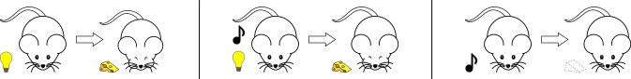

Theories[edit]

Data sources[edit]
Experiments on theoretical issues in conditioning have mostly been done on vertebrates, especially rats and pigeons. However, conditioning has also been studied in invertebrates, and very important data on the neural basis of conditioning has come from experiments on the sea slug, Aplysia.^{[15]} Most relevant experiments have used the classical conditioning procedure, although instrumental (operant) conditioning experiments have also been used, and the strength of classical conditioning is often measured through its operant effects, as in conditioned suppression (see Phenomena section above) and autoshaping .

Stimulus-substitution theory[edit]
According to Pavlov, conditioning does not involve the acquisition of any new behavior, but rather the tendency to respond in old ways to new stimuli. Thus, he theorized that the CS merely substitutes for the US in evoking the reflex response. This explanation is called the stimulus-substitution theory of conditioning.^{[16]} A critical problem with the stimulus-substitution theory is that the CR and UR are not always the same. Pavlov himself observed that a dog's saliva produced as a CR differed in composition from that produced as a UR.^{[6]} An even more striking is the finding that the CR is sometimes the opposite of the UR. For example: the unconditional response to electric shock is an increase in heart rate, whereas a CS that has been paired with the electric shock elicits a decrease in heart rate. (However, it has been proposed that only when the UR does not involve the central nervous system are the CR and the UR opposites.)

